Project Report Template

1. INTROUDTION

1.1 overview

* These centers serve as a hub for students to access online courses, video lecture and interactive simulations.

* Educonnected isn't just about providing hardware and software; its about fosterin a sense of community involvement.

1.2 Purpose

*Changing the way parents, students and educators discover research and review schools and educational programs.

* student centered ,engaging activities which are also self- checking and self- selecting. 2.Problem Definition &Design Thinking

2.1 Empathy Map

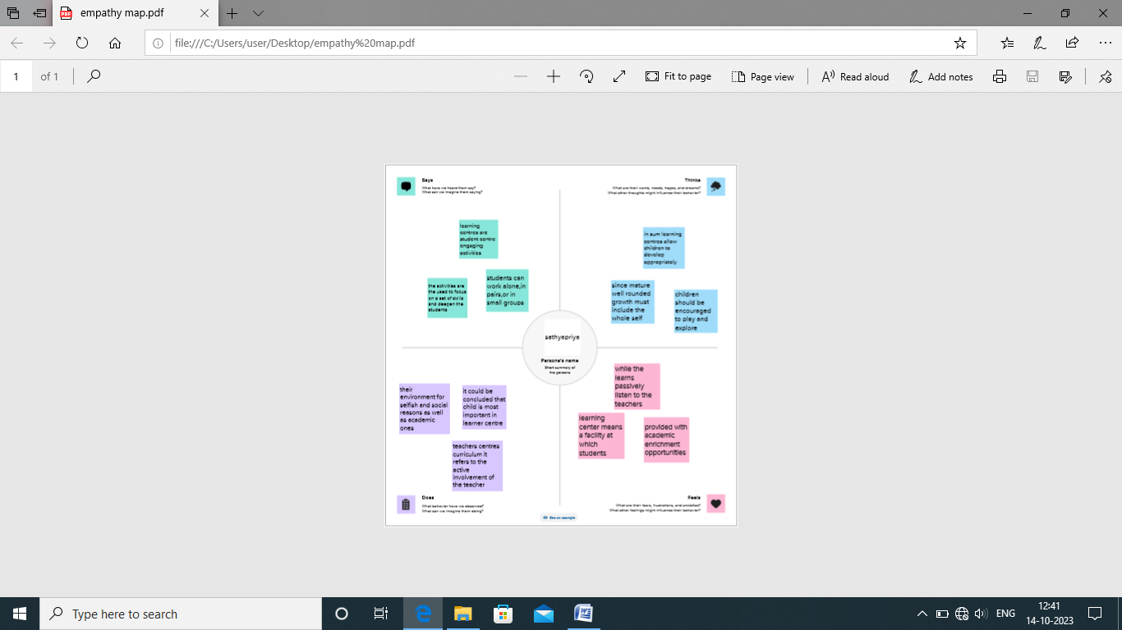

2.2 Ideation & Brainstorming Map

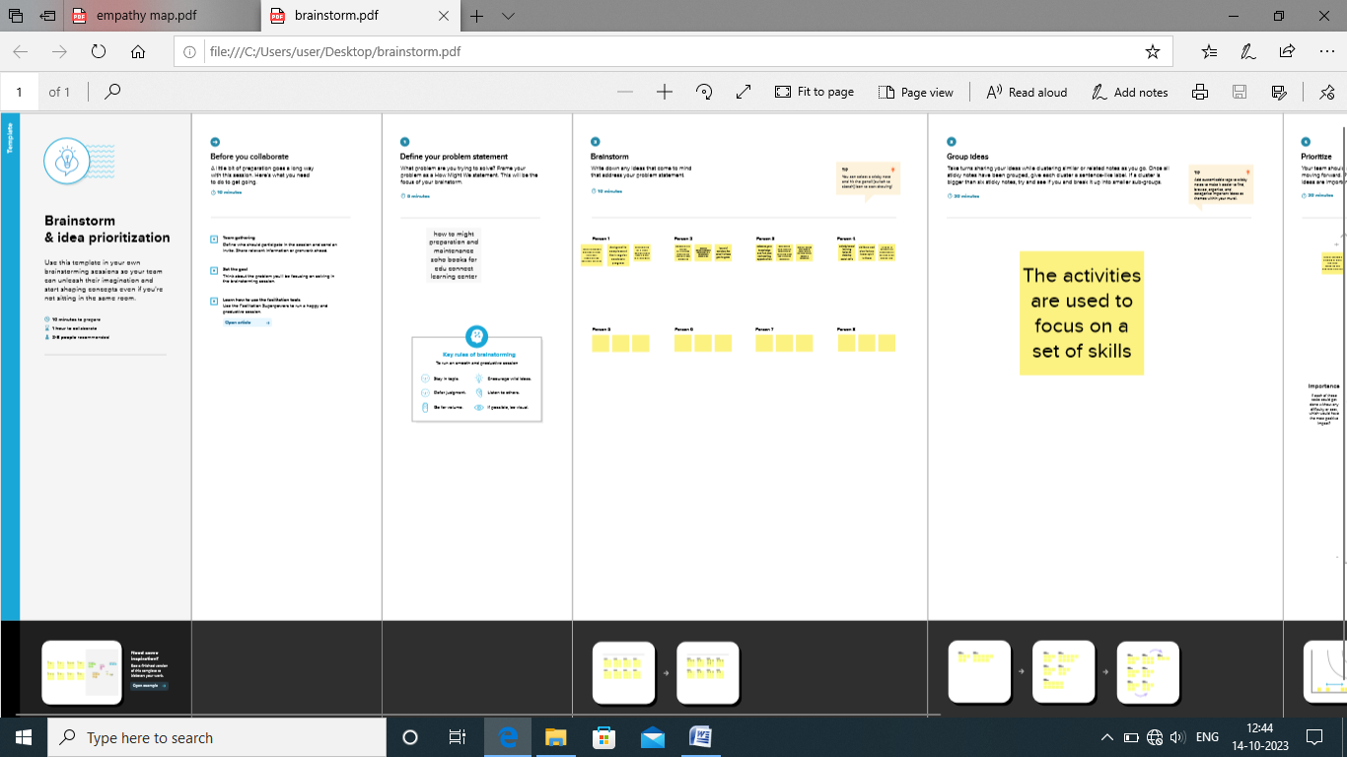

3.RESULT

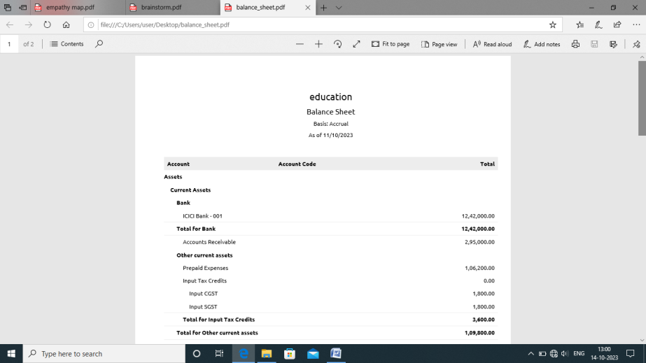

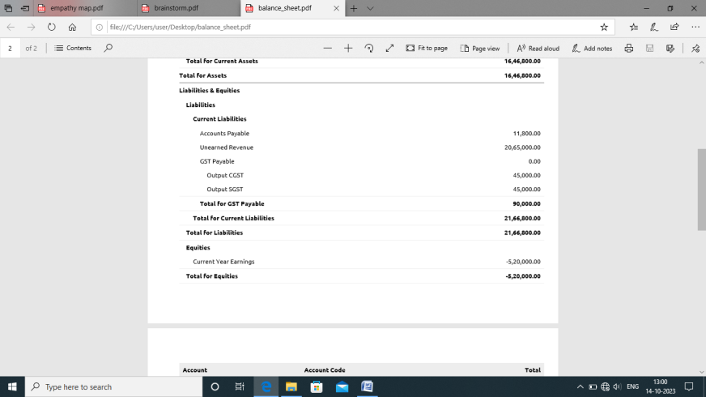

4. ADVANTAGES &DISADVANTAGES

ADVANTAGES

*They do have fixed hours and a brick and mortar location so you do have to go to

Them during those hours .

DISADVANTAGES

*Discipline problems are reduced because groups are limited to a number which

Can resonably function in each area.

5. APPLICATIONS

ZOHO BOOK

*zoho books is your one stock platform for managing your accounting task and

Organizing your transaction .

GITHUB

*Github is a code hosting platform for version control and collaboration

* it lets you and others work to gether on projects from anywere.

6. CONCLUSION

Thus the above program has been successfully executed

7. FUTURE SCOPE

Zoho plans to embrace transnational localism, adapting its products and services

To meet the specific needs of local markets while maintaining a global outlook.

8. APPENDIX

https://github.com/sathyapriya17/edu-connect-learning-center_NMTMID226052023/upload/main